**Name :** *Saad Bin Munir*

**Batch Code :** *LISUM06*

**Submission Date :** *1 March 2022*

**Submitted to:** *Data Glacier*

**API Link:** [*https://heroku-vaccine-classification.herokuapp.com/*](https://heroku-vaccine-classification.herokuapp.com/)

**Cloud and API Deployment on Heroku**

# **Writing Flask Application**

# **Writing template code**

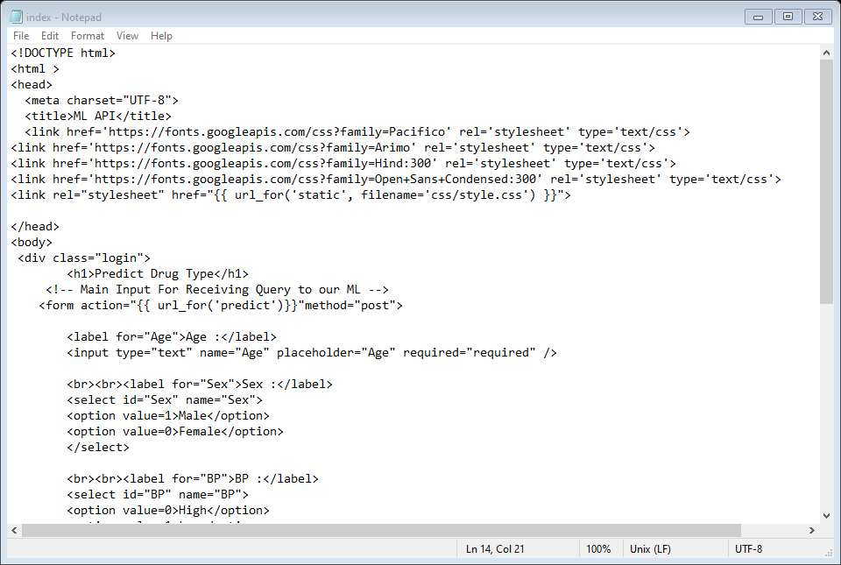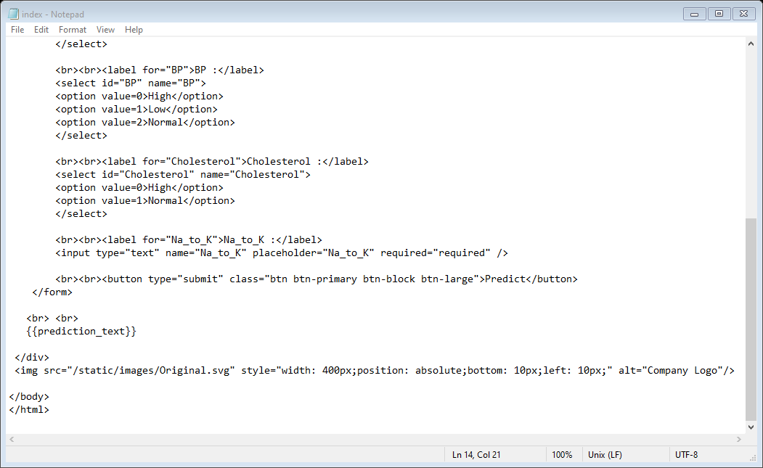

# **Create requirements.txt**

# **Create procfile**



# **Create New App in Heroku account**

# **Search for branch and connect**

# **Deploy Branch**

# **Open Link in browser**

The link is : <https://heroku-vaccine-classification.herokuapp.com/>

# **Test Model and Get results**

